Business Question and Visualization Report

Date | 19 september 2026
Team ID | MCA
Project Title | Smartphone Usage, Digital Addiction, and Well-Being Data Analytics
Maximum Marks | 5 Marks

Visualization development refers to the process of creating graphical representations of data to facilitate understanding, analysis, and decision-making. The goal is to transform complex datasets into visual formats that are easy to interpret, enabling users to gain insights and make informed decisions. Visualization development involves selecting appropriate visual elements, designing layouts, and using interactive features to enhance the user experience. This process is commonly associated with data visualization tools and platforms, and it plays a crucial role in business intelligence, analytics, and reporting
Business Questions and Visualisation
The process involves defining specific business questions to guide the creation of meaningful and actionable visualizations in Power BI. Well-framed questions help in identifying key metrics, selecting relevant data, and building visualisation that provide insights.

1: What is the distribution of users across different digital addiction severity tiers?
Visualization: Pie Chart showing addicted and not addicted users .

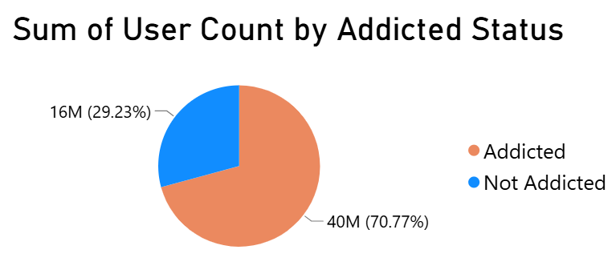

2: How do weekday vs. weekend screen time habits shift across different age groups?
Visualization: Line and clustered column chart showing weekday vs. weekend
Screen time habits shift across different age groups.
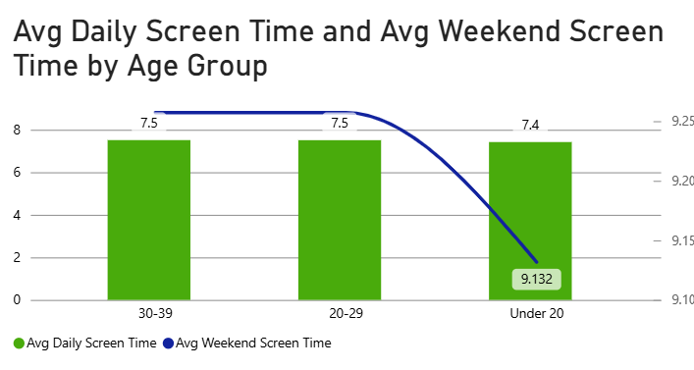

3: Which digital activities (Social Media vs. Gaming) dominate as daily screen time
rises?
Visualization: Clustered column chart showing digital activities (Social Media vs.
Gaming) dominate as daily screen time rises.

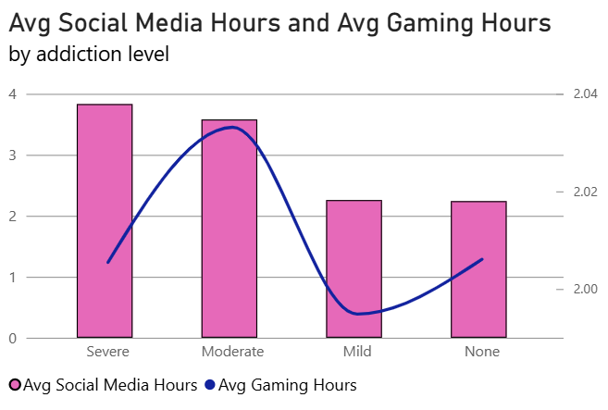

4: How does stress level correlate with compulsive checking behaviors (App Opens &
Notifications)?
Visualization: Scatter Chart showing how does stress level correlate with
compulsive checking behaviours (App Opens & Notifications) for every user-id.
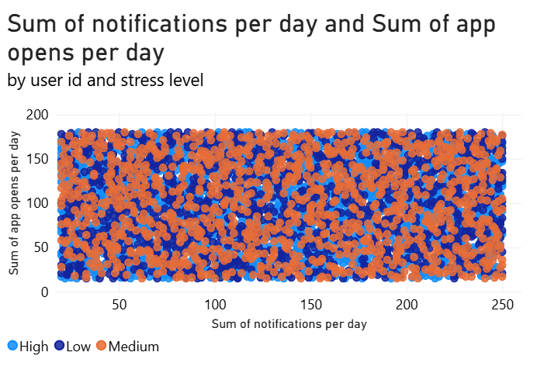

5:What is the operational impact of high screen time on student productivity and rest?
Visualization: Combo Chart showing operational impact of high screen time on student productivity and rest based on addiction level against avg work study hours and avg sleep hours.

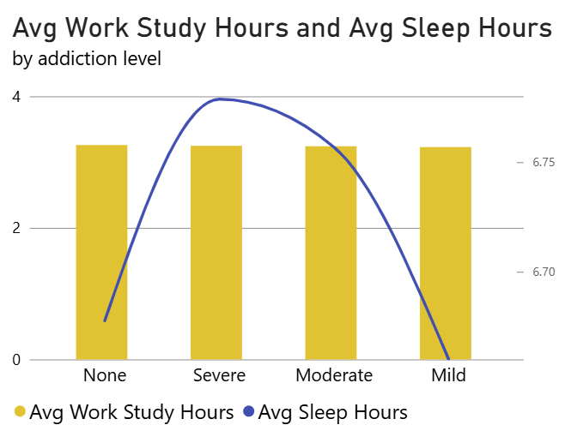

6: At what age threshold do average daily app opens and notification triggers reach their peak?
Visualization: Line Chart showing at what age threshold do average daily app opens and notifications triggers reach their peak.

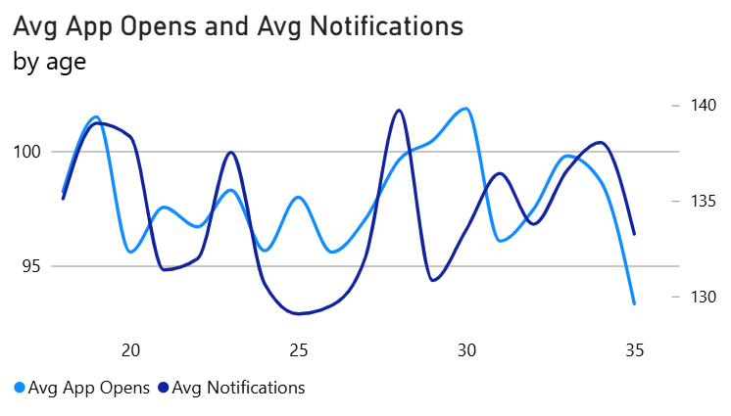

7: How do daily notification volumes accumulate and compare across different stress levels as age increases?
Visualization: Area Chart showing how daily notifications volume accumulate and compare across different stress levels as age increases.

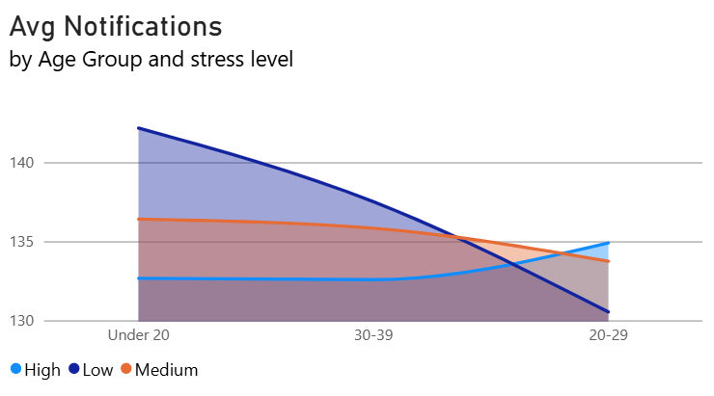

8: What is the gender breakdown among users flagged with an "Addicted Status"?
Visualization: Stacked Bar Chart showing the gender breakdown among users flagged with an "Addicted Status".

